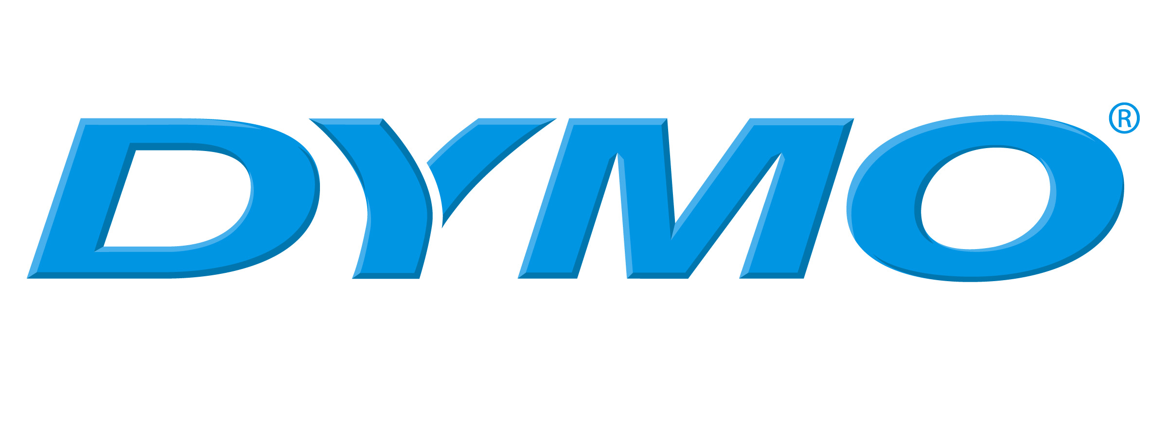 Material Safety Data Sheet
Date: June, 22nd 2007

Identification : Dymo Letratag tape
1. Company : Dymo bvba

Industriepark Noord 30
9100 St-Niklaas
Belgium
Telephone : +32 (03) 778 85 11
Fax : +32 (03) 776 51 81
- Composition – Hazardous components

Pressure sensitive tape, made from a polyester carrier and coated on one side with ink and acrylic adhesive. The adhesive is covered with silicon paper.

- Hazard Identification

The product is considered safe to health in its normal use. The product is a stable material. It does not decompose under normal conditions.

- First Aid measures
n.a.
- Fire Fighting Measures

5.1 Extinguishing media : water mist, foam, dry powder, CO₂ gas

  - Special fire fighting procedures : n.a.

- Accidental Release Measures

n.a.
- Handling and Storage

No special requirements for handling. Recommendations for best storage conditions : see paragraph 16
- Exposure controls/personal protection

The product is considered as totally safe to health in normal use. Do not apply onto skin for prolonged time. Possibility of sensitization is rare.

Special requirements : none
Protective gloves : none

Other personal protective clothing or equipment : none
- Physical/chemical Properties

  - Form: laminate
Odour : slight characteristic

  - Safety relevant data :
Boiling point : n.a.
Melting point : n.a.

Flash point : no data
Flammability : difficult to set on fire; only at elevated temperatures
Ignition point : n.a.
Self-ignition: n.a.
Explosion limits : Lower : n.a. Upper : n.a.
Vapour pressure : n.a.
Density : ~ 1. 3 g/m³

- Stability and Reactivity

Stable product. Does not undergo reactions under normal conditions of usage.
Decomposition products are : water, carbon monoxide and carbon dioxide.

- Toxicological information

In its approved use, the product is not toxic and does not release toxic substances.
Routes of entry : inhalation : no
skin : no
Ingestion : yes – do not ingest the tape
Health hazard (acute/chronic) : n.a.
Carcinogenicity : n.a.
Emergency and first aid procedures : none

12. Ecological information

The product is not hazardous to the environment when used under normal circumstances.

- Directions for waste proposal

Waste disposal method : small quantities can be disposed off as household waste, in accordance with local regulations.

Large quantities should be disposed off in licensed incinerators in accordance with governmental regulations

Transport information

International regulations:

Land: Rail/Road (IRD/ ADR) : not restricted

Sea: (IMO/IMDG) : not restricted

Air : (ICAO/IATA) : not restricted

- Regulatory information

None

- Additional information

  - Storage conditions

Recommendation is to store the product in the original packaging in a cool and dark place at following conditions : between 10-25 °C and relative humidity between 40-60 %.

  - Responsibility statement

This information should not be seen as guaranteeing specific properties. It remains the responsibility of the user to assess the risk of using the product. We encourage customers to develop their own test to qualify a product’s fitness for use in their actual application.

